Evaluation Questions

Directions: Select the evaluation questions that will work well for your team and what you want to learn about their experiences on the research team.
- You can involve your team in picking the questions that are most important to the whole team.
- You can ask these questions regularly during your project. You can also ask them at the end of the project.
- Some questions are open-ended. Other questions will need a Likert response scale. You can use the response options that will work best for your team.
These questions were gathered from evaluations other teams did.

Response options


Response option 1:

Yes

Kind of

No
I’m not sure

Response option 2:
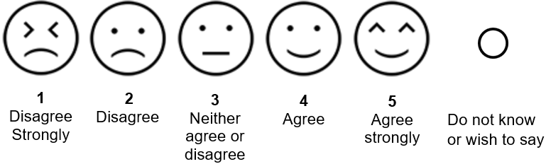

Response option 3:
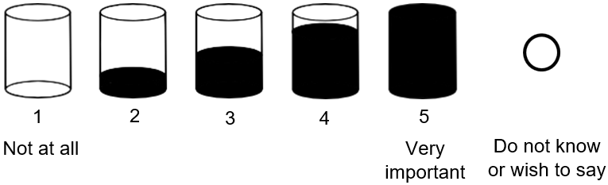

Team process
Questions about how well teams worked together.

Open-ended questions
- How is working with other members of [team name] going?
- How can we make our meetings better?
- What worked well?
- What should we keep doing?
- What hasn’t worked well? What should we change?
- What could we have done better?
- Is there anything [team leaders or staff] can do to improve how we work together?
- What did [project leaders] do that you would like to keep doing in future meetings?

Likert scale questions
- Most of the time, I feel like our team works well together.
- I didn’t feel rushed at this meeting.
- We could meet our goals at this meeting.
- We got our work done at this meeting.

Satisfaction/feedback
Questions about how happy you are with your experience on a project.

Open-ended questions
- How could we make [project name] better?
- What did you like most about [project name]?
- Do you have any ideas for making [project name] better?
- Do you have any concerns about [project name]?
- What did you like most about [project name or specific activity]?
- What did you like least about [project name or specific activity]?
- Would you participant in [project name] again?
- Would you recommend participating in [project name] to other people?
  - Why/why not?

Likert-scale questions
- I feel like we get things done at team meetings.
- I enjoyed my experience working on the [project name].
- I feel like the [project name] is important.

Communication
Questions about how happy you are with your experience on a project.

Open-ended question
- Did we communicate clearly between meetings?

Likert-scale questions
- I am happy with how we communicate between meetings.
- Team meetings are scheduled far enough ahead of time for me.
- I got all the information I needed about the project far enough ahead of time.
- Our team communicated well.

Accessibility
Questions about if the project was easy to understand.

Open-ended questions
- Is there anything you need to make it easier to be part of meetings or discussions?
- Did you feel like you could share your ideas? What helped you share your ideas? / What made it hard for you to share your ideas?

Likert-scale questions
- I can understand information at team meetings.
- I feel like I have the chance to share what I want during team meetings.

Inclusion/value
Questions about if you felt included and that your opinions were valued on the research team.

Open-ended questions
- Did you feel uncomfortable at any time? If so, when did this happen? How could we help you feel more comfortable?
- Do you feel comfortable sharing your experiences/ What helps you feel comfortable? / What makes you feel uncomfortable?
- How did you help the team?

Likert scale questions
- My team thinks my ideas are important.
- I feel like the things I say are valued.
- I feel included when my team makes important decisions.
- My team includes me in important decisions.
- I feel comfortable sharing what I think.
- I feel comfortable sharing my experiences.
- I feel like people listen to and understand my ideas.
- I feel like my experiences are valued by [team leader].
- The things I do on this project are important to me.
- Being part of the research team was important to me.
- My responsibilities on this project are important to me.

Individual outcomes for team members

Open-ended question
- What good things have happened for you because you were part of this team?

Likert scale questions
- I got something out of this project.
- Working on this project mattered to me.
- I am glad that I was part of the [project name] team.
- I value spending social time with the [project name] team.
- I am learning about research.
- The research project discussions were interesting.
- I feel prepared to help lead a research project.
- I am confident that I can help lead a research project.
- I have leadership skills I can use.
- I can lead a research team meeting.
- I can solve problems on a research project.
- I can help solve disagreements on a research project.

Specific project feedback

Open-ended questions
- What would you tell other people about this group?
- What do you think other people on the team learned from you?

References
The questions were taken from or adapted from:
- Virtual Community Engagement Studio Toolkit
  - Buell, J., Mazel, S., Zisman-Ilani, Y., Henning, S., & Nicholson, J. (2021). Virtual Community Engagement Studio Toolkit: For researchers and community experts interested in maternal mental health and/or substance use/recovery. Brandeis University.
- Sage Resource Toolkit: Developing and Working with Older Adult Research Advisory Boards.
  - The Sage Resource Project. (2022). Sage Resource Toolkit: Developing and working with older adult research advisory board. CJE SeniorLife.
- Example CBPR Check-in survey from the Academic Autism Spectrum Partnership in Research and Education (AASPIRE)
  - Nicolaidis, C. (2021). AASPIRE Outcomes Project. Example online CBPR check-in survey. AASPIRE.
- A Workbook to Support Community-Engaged Autism Research: Lessons from Project STEER
  - Wainer, A. L. & Walton, K.M. (2022). Workbook to Support Community-Engaged Autism Research: Lessons from Project STEER.
- El Futuro Process Quality Checklist
  - Smith L., Brock K., Perez Jolles M., Thomas K. (October 2017). Patient-Centered Outcomes Research (PCOR) Toolkit for Community Behavioral Health Organizations Serving Latinos. El Futor, Inc.
- Coalition for Recovery and Innovation in Traumatic Brain Injury Care Across the LifeSpan (CRITICAL) Patient Partner Interview Guide
  - Coalition for Recovery and Innovation in Traumatic Brain Injury Care Across the LifeSpan (2018). Patient Partner Interview Guide. University of Colorado Denver-Anshutz Medical Campus.

