Deciding what to share about your team’s research
[project logo or short title]


Directions:
Use this worksheet to brainstorm the main ideas your team wants to share about your research project. You can fill in this worksheet as a group or on your own.
When you work on this plan, think about who you are sharing with:
- What will help them understand what you did and learned?


Our research question was:



Who are we sharing with?


Information to share

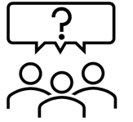
- Why did we do this study?
- What did we want to learn?
  - What was our research question?
- Why was it important to learn this information?

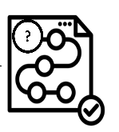
- How did we answer our research question? What information did we get or use?
- How did we get the information we needed?
- Explain who did what on the research team members.


- What did we learn?
- Did it match what we thought we would learn?
- Were we surprised by what we learned?
- Did you learn something you didn’t expect?


- What main points should we share?



- What does what we learned mean for people in their everyday lives?
- What does what we learned mean for services for people with disabilities?
- What does what we learn mean for policies?


- Are there any parts of our research that we would change if we could?
There are always ways to make our research better. Researchers need to think about how they can do their research better to make sure they get accurate information.

- What would you change so we could be more confident that the data we got is accurate?
- Would we change anything about how we do the study if we do it again?
- How could we get more information?


- What do we want to study next related to this project?

