Things to Think About for Research Travel

Planning for travel
Image | Description
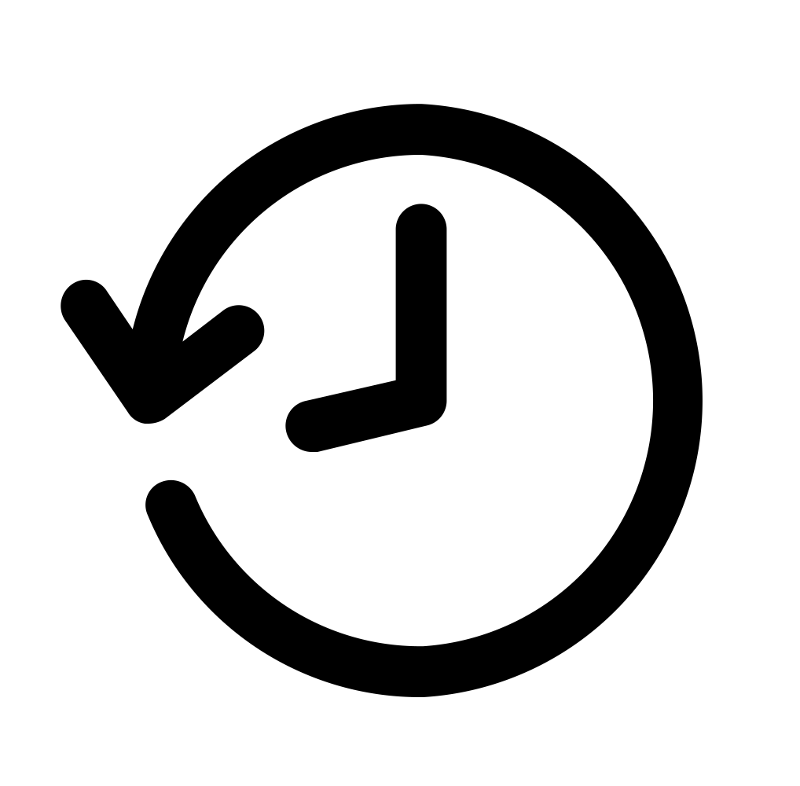 | Request early boarding or check-in for plane travel or lodging if it supports comfort.
 | Pay for as much as possible up front including transportation, lodging, or registration for events, so team members don’t need to pay out of pocket during the trip.
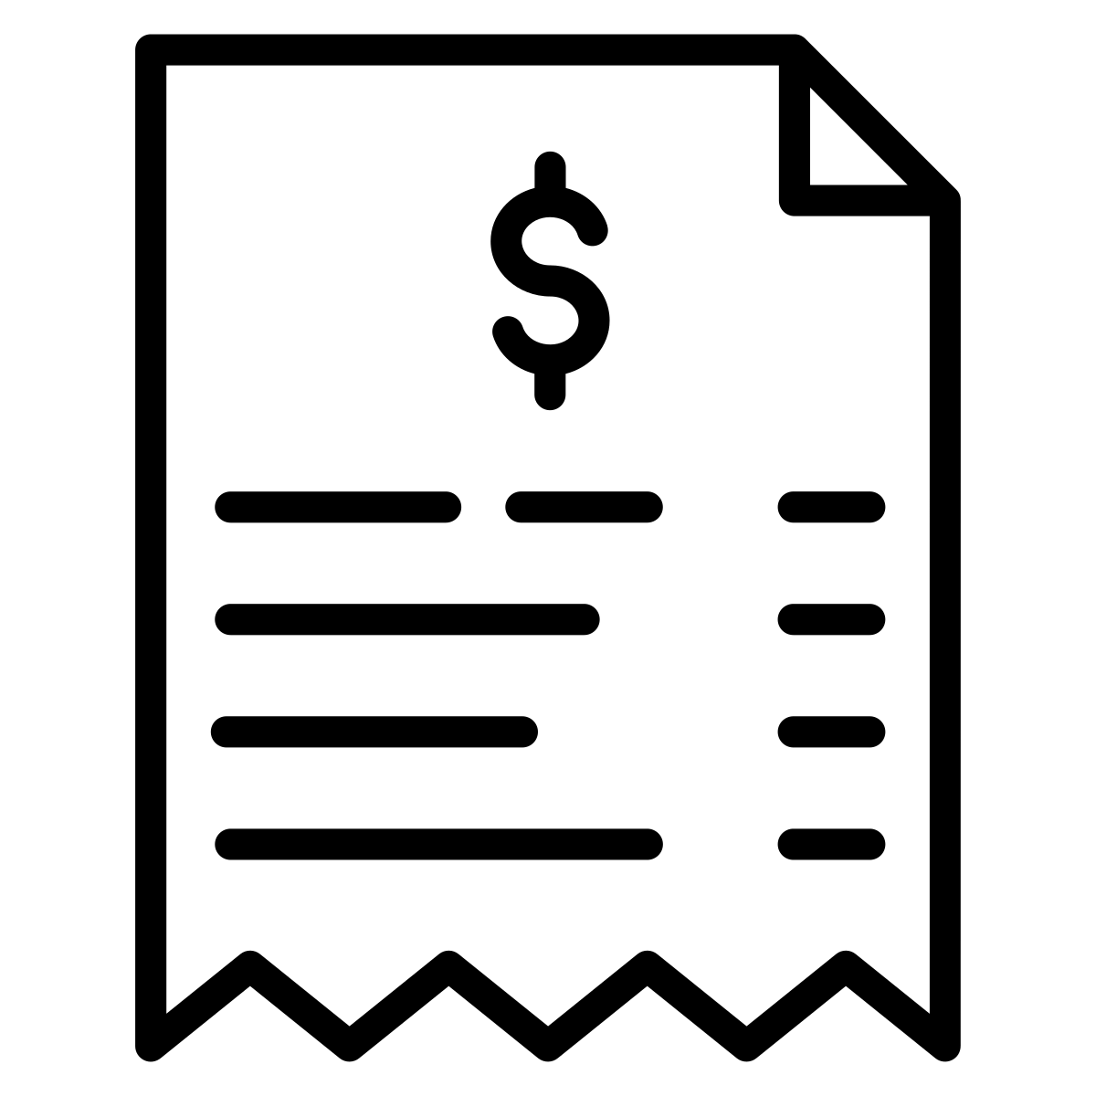 | Teach team members what receipts they need to save and how to save them. Make sure everyone knows:  - What can be reimbursed (i.e., meals, baggage fees);  - What cannot be reimbursed (i.e., souvenirs).

Budgeting for travel
Image | Description
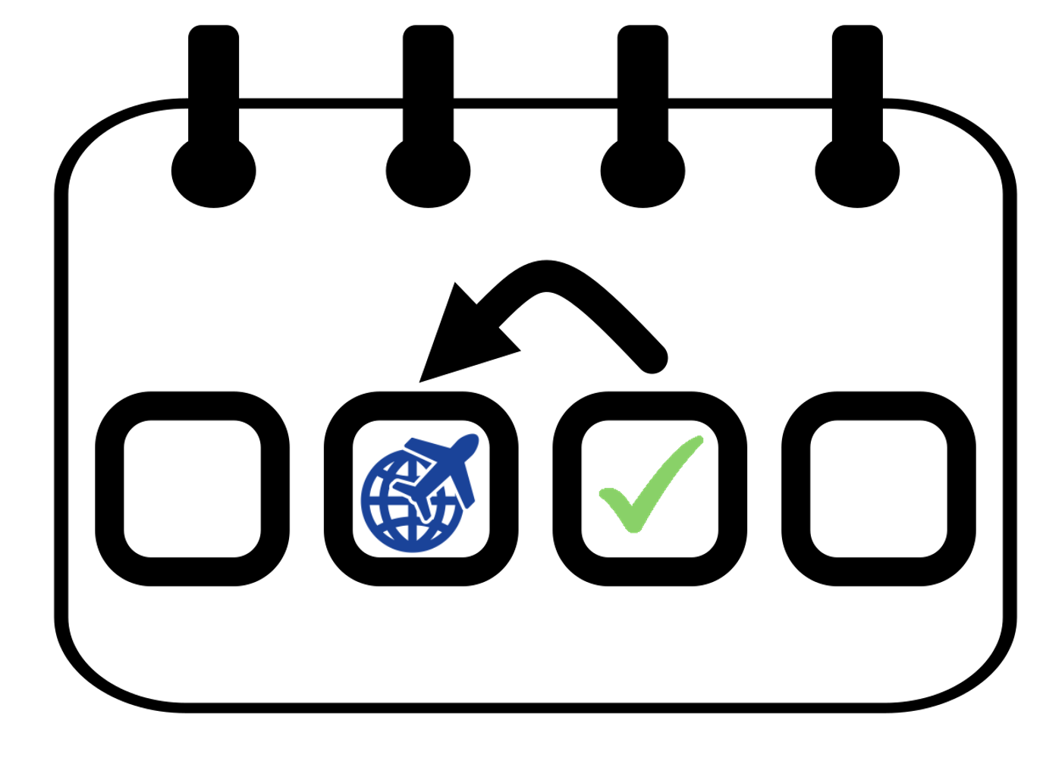 | Arrive a day before the activity as needed to adjust to time zones, recover from travel, become familiar with the environment, etc., so team members feel prepared and are not fatigued for the conference/ activity.
 | Provide funding for a support person to travel with a team member – this includes transportation, lodging, and meals.

Preparing to participate
Image | Description
 | Practice presentations or other planned contributions ahead of time.
 | Discuss unexpected situations that may come up, such as:  - Someone else taking extra time, reducing your time to present or do something;  - Technology not working;  - Changes to format of meetings.
 | Review the Accommodations Checklist to see if any other accommodations are needed for travel and participating in activities.

During the Trip
Image | Description
 | Identify which sessions, meetings, or activities each person will attend.  - Identify who will attend with the community research partner, if support is needed/desired.
 | Identify time to take breaks.
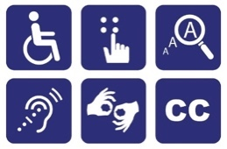 | If materials are available ahead of time, ensure they are accessible, for example by:  - Printing;  - Uploading to preferred devices (e.g., to support enlargement of font, screen reading, etc.).  - Review the Accommodations Checklist for more ideas.
 | Practice walking around the space and locating important rooms and/or resources.
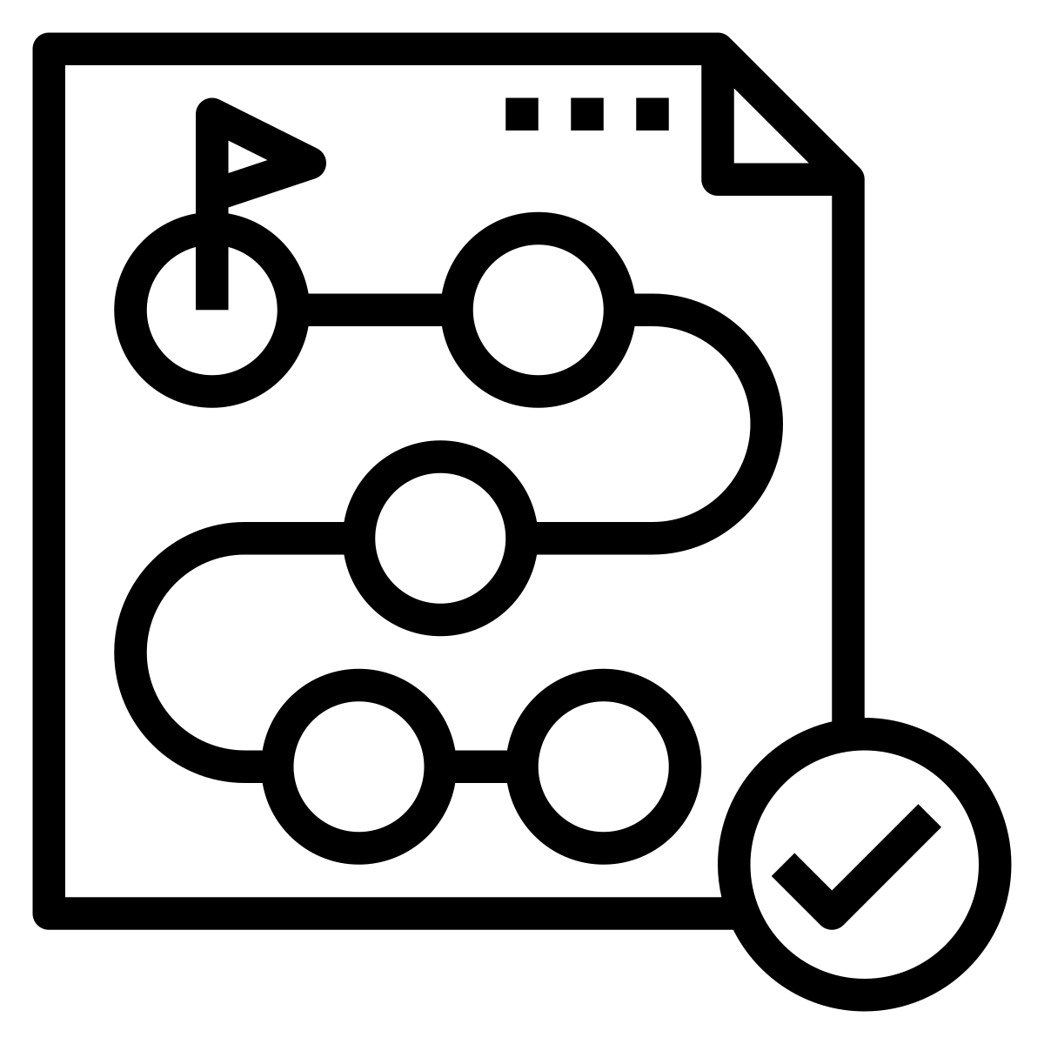 | Make a plan for what to do if part of the event or activity is inaccessible. This could include:  - Discussing or practicing how to leave a session or meeting;  - Discussing or practicing ways to find key information.
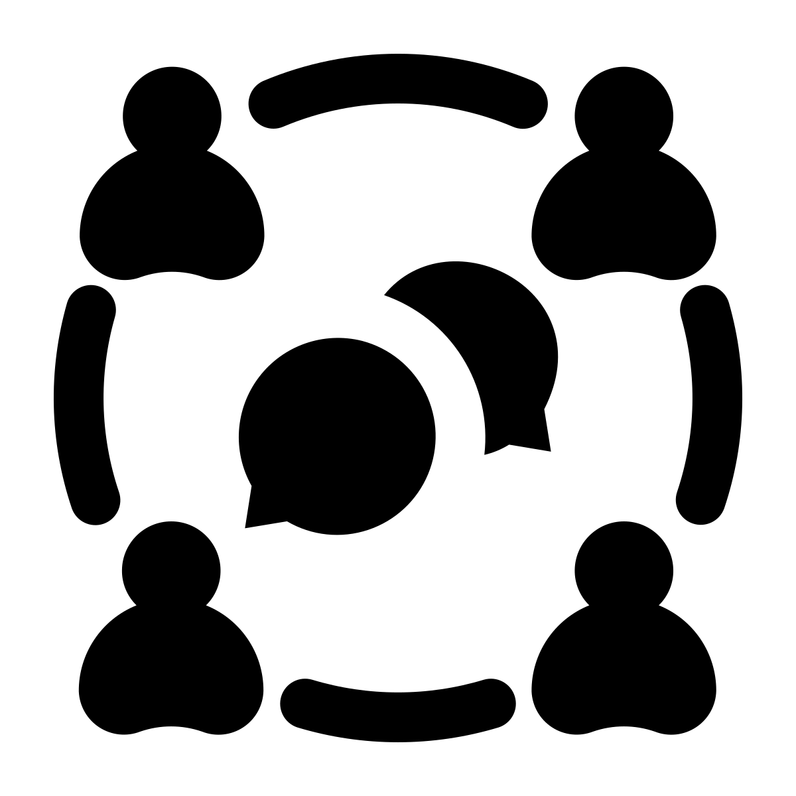 | Make a plan for social events, including who may accompany the community research partner.
 | Identify restaurants or meal options ahead of time that have options compatible with allergies and preferences.
 | Make a plan to introduce team members to colleagues to advance their careers and grow their networks.

