Solving Disagreements [project logo or short title]

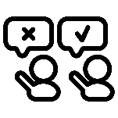
When we do research together, we share our opinions and ideas.
Sometimes we have different opinions about what we should do or how we should do it for our project.
There might be times when it is hard to agree on research project decisions. This can include:
- What to study
- If the team will meet online or in-person
- How to make decisions

This document has tools you can use when your team is having a hard time making a decision together. This may include times when people on the team disagree.

Tools
Tool | Type of tool | Why to use it
Worksheet to clarify opinions | Worksheet | To understand team members’ different opinions. This can be helpful when you are not 100% sure why or how you disagree.
Brainstorming ideas to solve the disagreement | Worksheet | To help come up with ideas for solving disagreements.  To think about the pros and cons of different ideas.
Consensus building using the 5-finger method | Method | To reach an agreement on a decision.
Private Sharing | Tips | Tips for when teams want to give people the chance to share their opinion privately.

Worksheet to clarify opinions
Sometimes we know we disagree, but we are not sure why. This worksheet can help us understand the different opinions everyone has.
Topic we are talking about:
Opinion A | Opinion B | Opinion C
What is the disagreement?
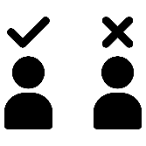

What do we agree on?

What information do we need to understand the disagreement better?

Brainstorming ideas to solve the disagreement
Fill out the table to brainstorm ideas to solve the disagreement.

Step 1: What are some ideas to solve the disagreement?
Click here for discussion questions that will help you or your team brainstorm ideas.


Step 2: Think about the pros and cons
- Think about how the idea will:
  - Affect the project.
  - Make people feel.
  - Help people work together.

Step 1. Ideas to solve the disagreement | Step 2. Pros | Step 3. Cons

What is the best idea to help the team move forward?
Why is this the best idea?

Guiding questions for brainstorming ideas to solve the disagreement
Step 1: What are some ideas to solve the disagreement?
- Is there something we can agree on?
- What do we agree on?
- Is there a compromise we can make?
- Is there something about the way we work we can change?
- Is there a different way we can communicate?
- Is there an idea that works for everyone?
Step 2: Think about the pros and cons
- Think about how the idea will:
  - Affect the project
  - Make people feel
  - Help people work together

5-Finger Method
The 5-finger method is a process for making decisions. It is not voting.
Here are the main steps:
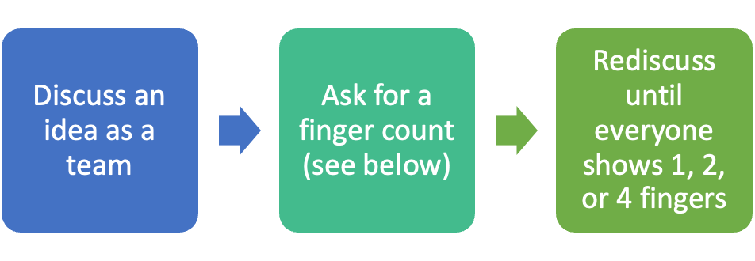
Score | Description
 | 1 - I love it!
 | 2 - I’m okay with it.
 | 3 - I can’t say yet – I would like more information or want to talk about it more. **
 | 4 - I don’t like it, but I won’t stop us from doing it. **
 | 5 - I hate this so much that I want to stop us from doing it. **
Team members can:
- Hold up their fingers
- Say their count out loud
- Type their count in the chat say

**If anyone gives 3, 4, or 5 fingers, the team will discuss and take another finger count. The people who gave 3, 4, or 5 fingers will explain why they voted that way.
A modification suggested in the Remote Inclusive Research Toolkit is to print the meaning of each finger/number on a notecard for each member to reference.
Citation for the 5-finger method: Nicolaidis, C., Raymaker, D., McDonald, K., Dern, S., Ashkenazy, E., Boisclair, C., … & Baggs, A. E. (2011). (2011) Collaboration strategies in non-traditional CBPR partnerships: lessons learned from an academic-community partnership with autistic self-advocates. Progress thin Community Health Partnerships: Research Education and Action, 011:5(2), 143-150

Private Sharing


You may have situations where team members feel most comfortable sharing their opinions privately or anonymously.

Some ways to share privately include:
- Survey about the decision;
  - This might include the options, what people want to do, and why they want to do it.

- 1-on-1 conversation;


- Anonymous discussion board;
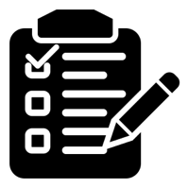

- Private voting using paper and pencil.

Tip: If team members want support to share privately, give them a choice for who provides support.

