Preparing for a meeting [project logo or short title]

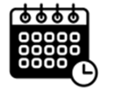 | Date and time of meeting:  [include time zones for all team members]

 | Who is invited:

 | Goal for the meeting:

Fill in this table to plan what you want to say at the meeting. You can have this document with you during the meeting as a reminder.

Slide number  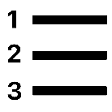 | Topic   | What I want to say  
Click here for directions and tips for using this document.

Directions and tips for using this document
This document can be used to review information before a meeting and plan what people want to say. It is designed to be used with slides.
If your team does not use slides to meet, you can change the table to make it work for you.
Section | Slide number   | Topic | What I want to say
What to do | If you are using slides, write the slide number in this column | Write what the slide is about | Write what you want to say

You can decide if you want to make a row for every slide.
Some people might want to only include the slides related to when they want to share.

Giving people support to prepare for a meeting

Different people may need different supports. Some examples include:

- Doing this worksheet with another person
- Another team member can write or type the slide numbers that will include discussion in the “slide number” column
- Another team member can write or type topic for each slide in the “topic” column
- Add a row for every slide, and highlight the parts that should be filled in
- Printing a document with extra space for larger handwriting

