How to fill out the PCORI Biosketch

What is a biosketch?

A biosketch is a form that tells about a person’s experiences and accomplishments. A biosketch is similar to a resume. Your biosketch helps you tell PCORI about yourself and what you will bring to the project.
Directions:
- Answer as many of the questions as you can. It’s ok if you need to ask someone for help to fill the biosketch out!
- After you fill out this form, you can transfer this information to the PCORI biosketch form or have someone do it for you.
- If you already have a resume, looking at your resume might help you fill out the biosketch.


Project role

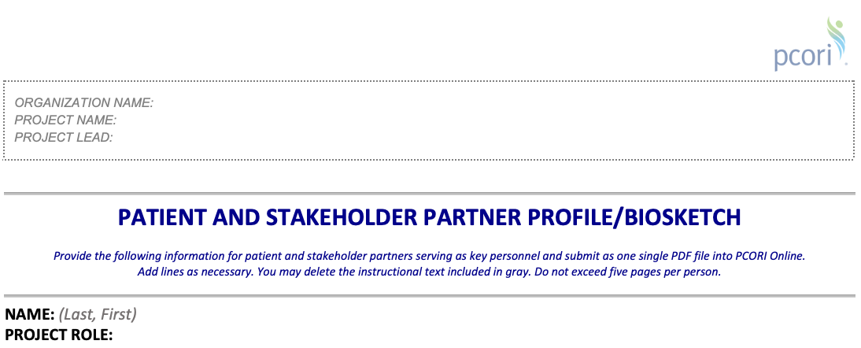

Directions:
Write what your job will be in the project (e.g., community research partner, steering committee member, research assistant, advisory board member).

Questions to think about:
- What will you do in this project?

Examples:
- Help lead the project
- Decide what the project should be about
- Decide how to do the project
- Give feedback on how do the project
- Help people work together and share their ideas
- Help create materials for the project
- Collect information (or data) for the project
- Help create an intervention
- Help deliver an intervention
- Figure out what the information you collected (data); means – this is also called data analysis
- Share what you learned in the project with other people

Professional/personal statement

Directions:
Write about what you will add to this project. Talk about your experiences and why this project is important to you in 4-5 sentences. You may use the same information that you use in your letter of support for the project proposal [link LOS document].

Questions to think about:
- Why do you want to work on this project?
- Have you ever worked on something similar?
- Why is this project important to you?

Example:
I have led self-advocacy meetings, helped plan Special Olympics events, and organized inclusive art workshops.
These experiences have shown me how important it is for people with disabilities to have the chance to lead and be speak out about what is important to us.
I believe this project is important because it will help create more opportunities for people with disabilities to succeed and speak up for themselves. I will be able to use my experiences to help the team make decisions about research.


Experience, leadership, and engagement

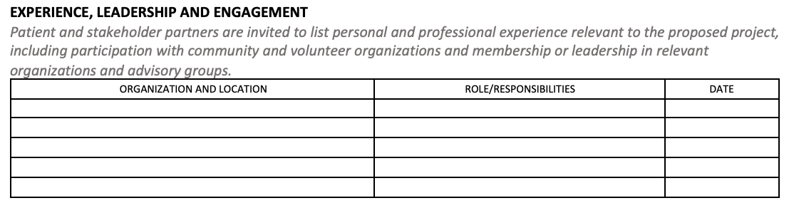

Directions:
Fill in the table to describe what you’ve done in your community, at work, or on other projects.

Think about all of the experiences you have had related to the project.
- Have you ever been in a group, club, or team?
- Did you help plan something, share ideas, lead or mentor others?
- Have you done anything related to the project before? For example, have you been involved in a fundraiser or advocacy for a health condition or disability rights?

Examples:
ORGANIZATION AND LOCATION | ROLE/RESPONSIBILITIES | DATE
Self Advocate Leadership Committee, Arc of New Orleans, LA | Led self-advocacy meetings  Taught people self-advocacy skills  Hosted fundraisers | 2018- present
Inclusive Arts Program, Phoenix, AZ | Helped plan and run art classes and events  Showed my artwork at 2 art shows  Worked with other artists to create a mural for a local store | 2019 and 2021
Adaptive Sports of Boston, MA | Helped plan sporting events  Supported teammates during practice  Met with new athletes to make them feel welcome | 2015-2017


Engagement in research

[You will only do this section if you have been part of a research team before.]
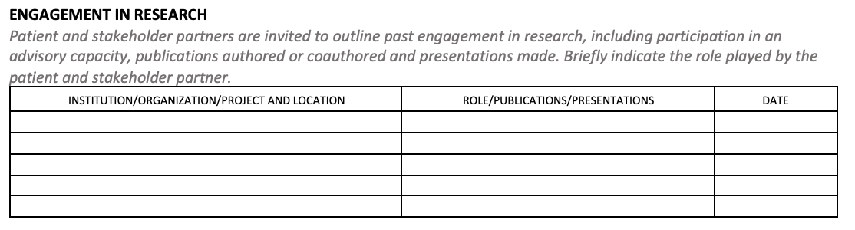

Directions:
Fill in the table to describe the research experiences you have had.

Think about different experiences you might have had.
For example:
- Did you help plan something, share ideas, or give feedback?
- Did you help write something, like a paper, or talk about research at a meeting or event?

Examples:
INSTITUTION/ ORGANIZATION/ PROJECT AND LOCATION | ROLE/ PUBLICATIONS/ PRESENTATIONS | DATE
Organization: Healthcare advocates of New Orleans  Project: Meeting the Needs of Cancer Survivors with Disabilities  Location: New Orleans, LA | -Gave feedback on how to do the research  -Interviewed people  Presentation: “We want choices!: What cancer survivors with disabilities need.”  Presented at the Southeastern Cancer Conference in 2018. | 2017-2019
Organization: Community Health Research Group  Project: Understanding Barriers to Healthcare for People with Disabilities  Location: Boston, MA | -Helped design surveys and interview questions  -Helped interview people with disabilities  Publication: “Overcoming barriers: healthcare access for people with disabilities”  Published in Journal of Disability, 2022 | 2020-2022
[add your experiences]

Other

Directions:
Write about anything else that shows why you’re a good fit for the project. It can be hobbies, skills, or experiences that don’t fit in the other sections. You can also include any education, certification, or awards you have received.


Examples of things to share:
Things I am good at are:

My education includes:

My certifications or trainings include:

Awards I have gotten are:

Software and technology I use:

