Meeting Planning Tips

General meeting planning tips
Image | Description
 | - Give options for people who can’t come to the meeting:  - Meet 1-on-1  - Record the meeting (video or audio)  - Share meeting notes  - Hold 2 meetings
 | - Send meeting materials at least 1 week before the meeting.  - Ask what kind of meeting materials are best (agenda, slides with agenda, audio or video descriptions).  - If all materials are not ready, send what is ready before the meeting.  - Depending on what type of feedback is wanted, there might be times where it is ok to not send materials in advance.
 | - Put all meeting materials in the calendar invitations.
 | - Give team members the option for how to review the materials and teach them how to access materials.  - Review materials on your own (read materials, watch a video about the materials).  - Review materials at a pre-meeting (1-on-1 or in a group).  - Use text-to-audio software.
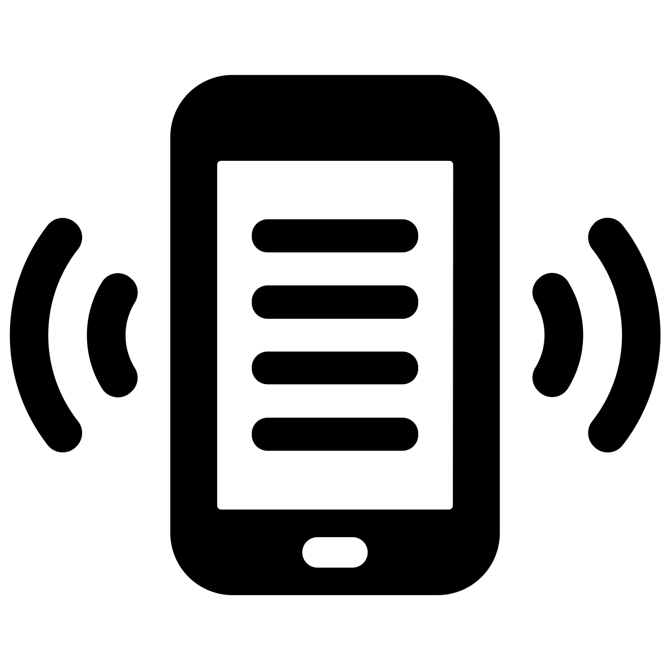 | - Send meeting reminders.  - Ask if people like to have text, call, email, and/or calendar invitations  - Ask when and how often they like to be reminded  - Do what each member of the team asked you to do
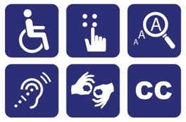 | - Make sure all materials are accessible.  - Some things don’t work for everyone – send each team member materials that are accessible for them.
 | - Ask people how they prefer to participate in meetings:  - In person  - Online
 | - Decide how you will get feedback on the meeting.  - Give the option to give private feedback.  - Use feedback from previous meetings to plan your next one.

Tips for planning virtual meetings
Image | Description
 | - Include links for meetings in the meeting reminder.
 | - Have an option to log in early to chat casually and make sure technology is working.
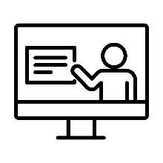 | - Teach everyone how to use the meeting software.
 | - Make a group agreement about how to use chat features.
 | - Make a group agreement about having cameras on or off.
 | - Make a group agreement about muting microphones.
 | - Make a group agreement about screen sharing so everyone can see the same information.  - Make sure it is big enough so everyone can see.  - Read the information out loud.
 | - Use breakout rooms for small group work.
 | - Print and mail materials if people want copies of materials.  - Mail the materials far enough ahead of time for people to get them.
 | - Make sure there is enough time for everyone to share in the way that works best for them (for example, type, talk, use a device).  - Talk about what it looks like when someone is done sharing and when it is ok to move onto the next topic.
 | - Have someone in person or online to provide support for people who want it.  - Someone online could help using chat or breakout rooms.
 | - Schedule breaks.

Tips for planning in-person meetings
Image | Description
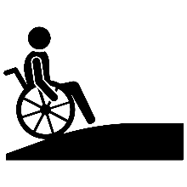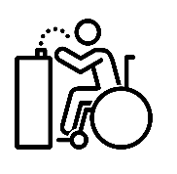  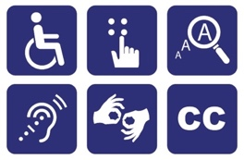   | - Meet in an accessible space.  - Physical accessibility:  - Wheelchair accessible (getting in and around the building, facilities such as bathrooms and water fountains)  - Everything people need (accessible bathrooms are on the same floor as the meeting room)  - Sensory accessibility:  - Lights, sounds, smells, fidgets.  - Enough space between seats so people are comfortable.
 | - Provide snacks.  - Consider allergies, needs, and preferences. Different people’s bodies need different things.
 | - Support people with transportation.  - Help them get rides  - Help them make a plan to use public transportation or paratransit  - Pay for transportation and parking
 | - Schedule breaks.  - Have options for what to do and where to go during the break.  - Give people enough time for the break.  - Consider using color-coded cards or other ways for people to let others know if they want to be social or not during breaks.
 | - Make plans for service and emotional support animals.  - Plans for animals to use the bathroom  - Plans for people allergic to animals  - Plans for people uncomfortable with animals
 | - Pay for things people need to attend the meeting. This might include:  - Transportation (including parking)  - Childcare  - Meal  - Extra staff time (for example, support staff who come to help)

