Meeting Agenda and Notes
[project logo or short title]
You can choose which parts are a good fit for your team. This document contains:
- A meeting agenda
- Note-taking worksheet organized by meeting topic
- Planning for the next meeting
- A meeting wrap-up

Meeting Agenda
[project logo or short title]
 | Date and time of meeting:  [include time zones for all team members]

 | Where we are meeting:

 | Who is invited to the meeting:

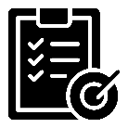 | Goal for the meeting:

What we will do  | How we will do it  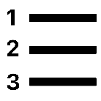

Meeting Notes
[project logo or short title]
Date and time of meeting:
[include time zones for all team members]

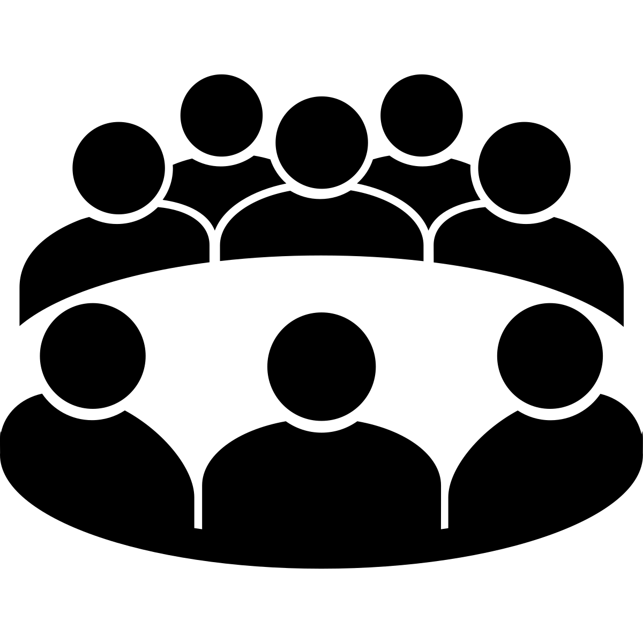 | Who was at the meeting:

Goal for the meeting:

What we did or talked about  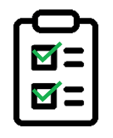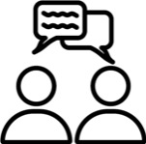 | How we did it or how we decided | What did we decide?   | Next steps  

Next meeting:
Date and time of next meeting:
[include time zones for all team members]

Topics for next meeting:

 | To do before the next meeting:

Meeting Wrap Up

 | Feedback on the meeting
 | How did we work together?
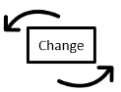 | What should we change?
 | What should we keep?

How team members helped the group
When we think about how everyone helped the group, we celebrate our teamwork.

Thinking about how everyone helps the group also can help everyone feel more connected to the project, because they can see how they are making a difference.

Name | This person helped the group by….  

Thinking about representation

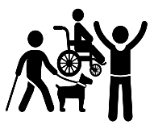
When we think about representation, we are thinking about people who have all types of races, genders, ages, disabilities, religions, and live in different places.
It is important to make sure our research is respectful to everyone and includes everyone.
- Did we think about how people with different backgrounds may feel about our research?
- Did we think about how people with different backgrounds may use what we made or are making?
- Did we think about how people with different backgrounds may feel about the decisions we made?
- Did we think about what we are doing will work for people with different backgrounds?

