Email Tips
Image | Description
 | Use subject lines that say what the email is about and if there is a deadline for any actions.  - When appropriate, add “important” or “please read” to the subject line.  - Add your team’s project name or team name to the subject if that helps people.
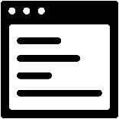 | Use a consistent email format so team members know what to expect.
 | Give attachments file names that say what the attachment is about.
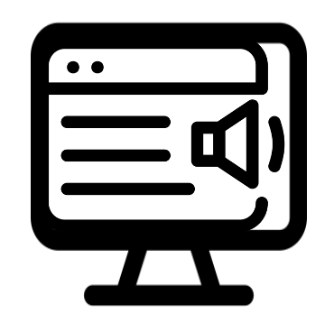 | Share files that are screen-reader accessible.
 | Offer a follow-up phone or video call to talk about the email.
 | Use accessible font and font sizes.
 | Use plain language and keep text short.

