Making Choices about Collecting Information to Answer Your Team’s Research Question [project logo or short title]
Directions: Use this worksheet to make decisions about how your team will collect information (data) from or about the people who are in your team’s study.
Data collection: Getting information (data) to answer your team’s research question or questions.

This worksheet includes three types of things:
Image | Description
 | Information to read on your own or together
 | Discussion topics to talk about with your team
 | Activities to help your team make decisions
Instructions to tailor this worksheet: Use the parts of this document that will help your team. Some teams may want to learn all of the information on this document. Other teams might only want to learn about the ways to get research information that is related to their project.

You can change the way you present the information to support your team. In some cases, you might need to add information or examples.

Activity: What type of information do we need?


- Our research question is:

The ways you can answer your team’s research question depend on what you need to learn. You will also have to think about the resources and time you have to do your team’s project.

- Circle or highlight the type of information you need to answer your team’s research question.
Image | Description
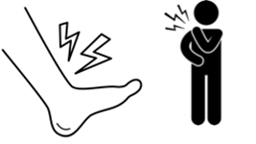 | How people’s bodies feel
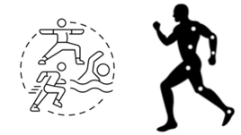 | Things people’s bodies do
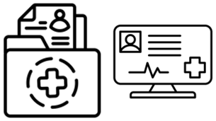 | Health information or medical records
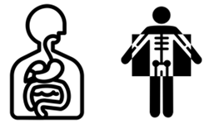 | What is in people’s bodies
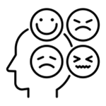 | People’s feelings
 | What people think
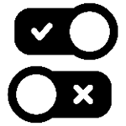 | If something does or does not happen. For example, if someone does or does not get sick.
 | What people do
 | Experiences people have or used to have

Information: Ways to get research information

There are many different ways to get information to answer your team’s research question. Here are some examples. Your team might have other ideas.

Way to get information | What it is
Survey  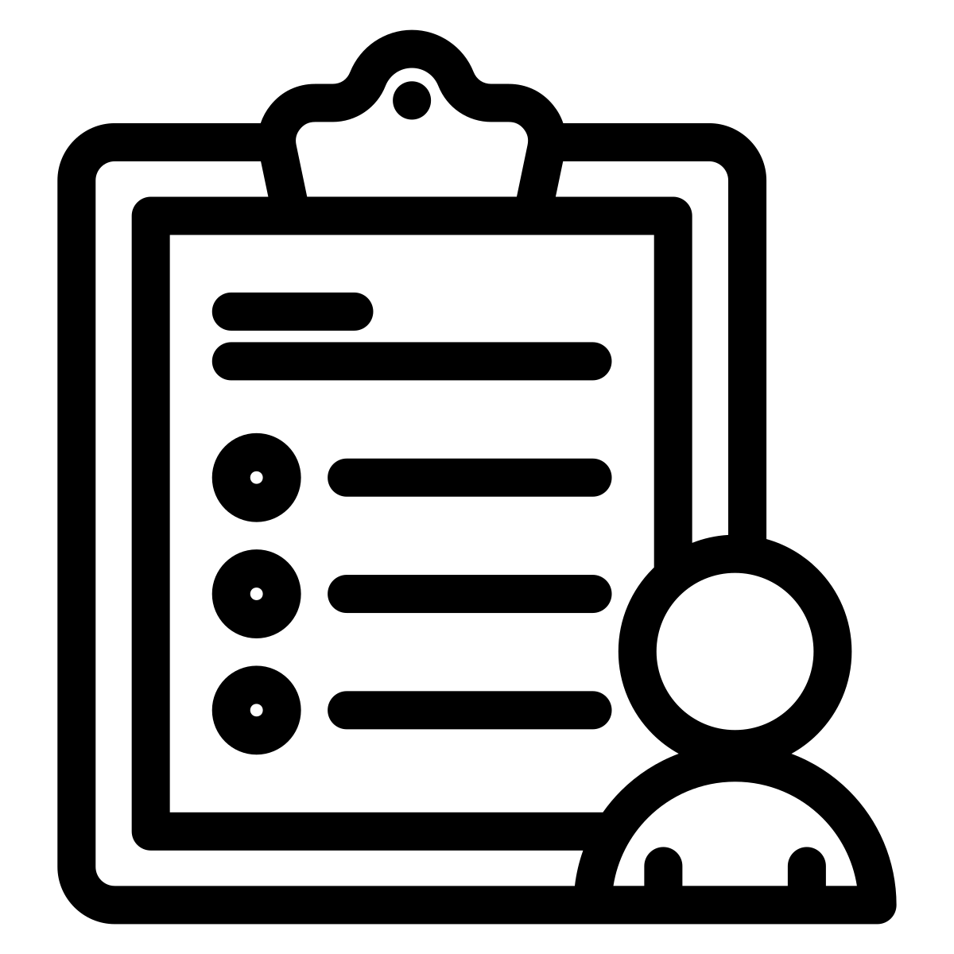 | A list of questions people answer. They can answer the questions on paper or on the computer.
Interview   | Talking to someone 1-on-1.
Focus group   | Asking people questions in a group.
Ask people to do art or make something   | People draw, make videos, act, or take pictures to share their ideas, experiences, or feelings.
Look at what people do or say on social media   | Writing down what people do or say on social media.
Information about locations   | Writing down where someone is or where something happens.
Observation (watching people)   | Watching to see what people do. This could include how they respond to different situations.
Blood test  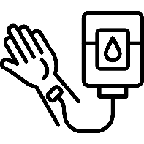 | Looking at someone’s blood for different things that show how their body is working.
Body measurements  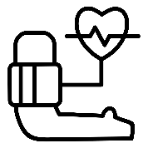 | Taking a measurement related to people’s body. This could include:  - Height  - Weight  - Blood pressure or pulse
Physical test  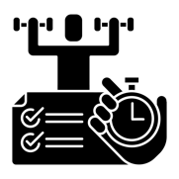 | Asking people to do different things with their bodies. Examples might include:  - Lifting weights  - Stretching  - Walking
Medical images  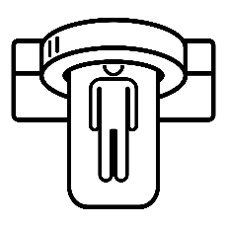 | Taking pictures to see inside someone’s body.  Examples include:  - MRI  - X-Ray  - CT Scan
Technology you wear  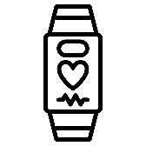 | Wearing a watch or other kind of technology that takes measurements of things people’s bodies do. For example, how much or how well they sleep, their heart rate, or how many steps they take.
Counting if something happens  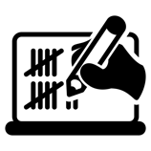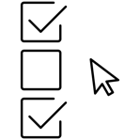 | Writing down if something happens. This could include:  - When someone got sick or hurt  - When someone got services  - When someone did an activity, like exercise or meditation
Counting when something happens  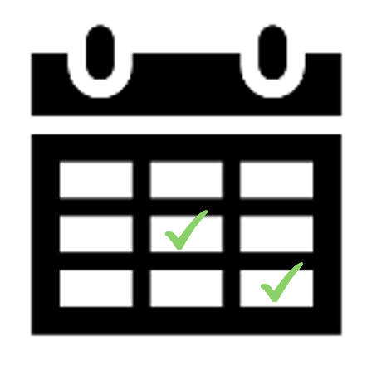 | Writing down the date something happens. This could include:  - When someone got sick or hurt;  - When someone got services.
Finding information in medical records  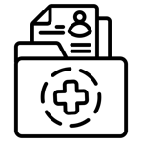 | Looking in medical records to learn information. This could include:  - What people’s physical or blood tests said  - If someone got sick  - The types of services they got

Discussion: Talk with your team about the different ways to get information.

Talk with your team about the different ways to get information. Think about what would help your team get the information you all need to answer your research question. Sometimes, you will need more than 1 way to get information.

If your team needs help deciding between different ways to get information, you can use this table to help you make a decision.

Type of information we need to know:
- Find 2 ways you can get the information you need to know.
- Write the ways in the table below.
- Think about the questions in the table to pick which way your team will get information (collect data).
Circle or highlight, Yes, No, or Maybe.
- After you finish the table, talk about which way of getting information (collecting data) will be best for your team.

Things to think about | Possible way to get this information 1: [type the way you can get the information] | Possible way to get this information 2: [type the way you can get the information]
Will people be comfortable doing this?   | - Yes  - No  - Maybe | - Yes  - No  - Maybe
Is it accessible?  If it isn’t, can we make it accessible?  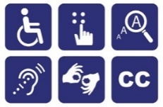 | - Yes  - No  - Maybe | - Yes  - No  - Maybe
How long will it take?   | - Yes  - No  - Maybe | - Yes  - No  - Maybe
Will it help us get the information we need?   | - Yes  - No  - Maybe | - Yes  - No  - Maybe
Another question: | - Yes  - No  - Maybe | - Yes  - No  - Maybe
Another question: | - Yes  - No  - Maybe | - Yes  - No  - Maybe

Making Tools to Collect the Information We Need

Information: What are data collection tools?

Data collection tools: the things we use to get information. This could include:
- Surveys
- Tests you do in a clinic or at the doctor
- Technology you wear
- Interview or focus group questions
- Cameras and directions for the types of pictures people take
Your team might already have a tool they want to use. Or, you might work together to make data collection tools. This worksheet has ideas for ways you all can work together to make data collection tools.

Information: Ideas for making data collection tools together - Interviews and focus groups

Brainstorming interview or focus group questions
- Look at what other people asked to learn about something similar.
- Share ideas in a group discussion.
- Talk about your experiences with the research question and have someone take notes. Use the notes to make questions that will help someone else talk about the same topic.

Making decisions about interview or focus group questions
- Use the ways your team makes decisions.
- Vote for the questions you think will get the best information.
- After you have a list of questions, practice asking them – do people share the type of information you need when you ask your questions?
- Sort the questions into groups of similar questions. Pick the question that is easiest to understand or does the best job getting the information you need.
- Ask people the questions to see if they make sense.

Information: Ideas for making data collection tools together - Surveys or Questionnaires

Picking a survey or questionnaire
When you pick a survey or questionnaire, it can be helpful to look at the surveys and questionnaires that already exist. Use the Evaluating Outcome Measures tool to help your team pick one. You can find this tool on the Equipped to Engage Planning Research webpage.
Sometimes surveys or questionnaires are not very accessible. Here are some things you can do to make surveys more accessible:

- Put the questions in plain language:
  - Simple words
  - Short sentences
  - Simple grammar
- Take out “figures of speech” and use straightforward language. Figures of speech are things like “it’s raining cats and dogs” that can be hard to understand if English is not your first language or you like straightforward language.
- Add examples
- Add pictures that are related to the question
- Add clear directions

If you make changes, it is important to:
- Try to make sure that questions mean the same thing before and after you change them.
- Remember that the numbers you get from the surveys or questionnaires may not be the same as the numbers you would have gotten if you had not made the changes. That means you might not be able to compare what you learned to another study that used the same survey, but didn’t change it.

Information: Making Data Collection Accessible

It is important to think about how data collection will be accessible for community research partners and research participants.

Tips for making data collection accessible:
- Think about doing activities to help people express themselves in different ways. Examples include:
  - Using pictures
  - Sorting activities
  - Group discussions and activities
- Review your accommodations checklist.
  - Think about what you will do during data collection. Do you need any different accommodations for data collection?
  - Will any of these accommodations help research participants?
    - What accommodations will you give to everyone?
    - What accommodations will you offer to people, but not make part of all data collection?
- Give people breaks.
- Let people know what will happen ahead of time.

Resources
- The Remote Inclusive Research Toolkit includes some ideas for making data collection accessible.
  - Accessibility for community research partners:
    - Using audio recorders
    - Using scripts
    - Having a tip sheet
  - Accessibility for participants:
    - Collecting data with pictures or visuals

