Figuring out what your team learned from the information (data) you collected [project logo / short title]

Directions: Figuring out what your team learned from the information (data) you collected is called data analysis. Use this worksheet to make decisions about data analysis.

Data analysis means Figuring out what the research information your team collected means.

This worksheet includes three types of things:
Title | Description
 | Information to read on your own or together
 | Discussion topics to talk about with your team
 | Activities to help your team make decisions
Instructions to tailor this worksheet: Use the parts of this document that will help your team. Some teams may want to learn about lots of different ways to analyze data. Other teams may want to focus only on what they might do for their project.
You can change the way you present the information to support your team. In some cases, you might need to add information or examples.

Activity: What are we trying to learn?

- Our research question is:

- The type of research information we collected is: (put a check next to all that apply)
- Numbers (“quantitative” data);
- Words (“qualitative” data);
- Pictures, videos, or another kind of art (“qualitative” data);
- Something else:

Discussion Topic: Who will do what?

Directions: Use the worksheet below to make decisions about who will do different parts of data analysis. There will be some things that team members who went to school for research will do. There will be some things that community research partners with disabilities do. There will also be some things that many people do.
Instructions to tailor this worksheet: You can add or take away tasks that make sense for your team’s project.

Data analysis with numbers (quantitative data)
- Task | - Do we need to do it? | - Who will do it?
Enter the information (data) into a computer program.   | - Yes  - Maybe  - No
Make sure that all the data we have is correct.  -The data is from real people.  -There aren’t mistakes.   | - Yes  - Maybe  - No
Count data.  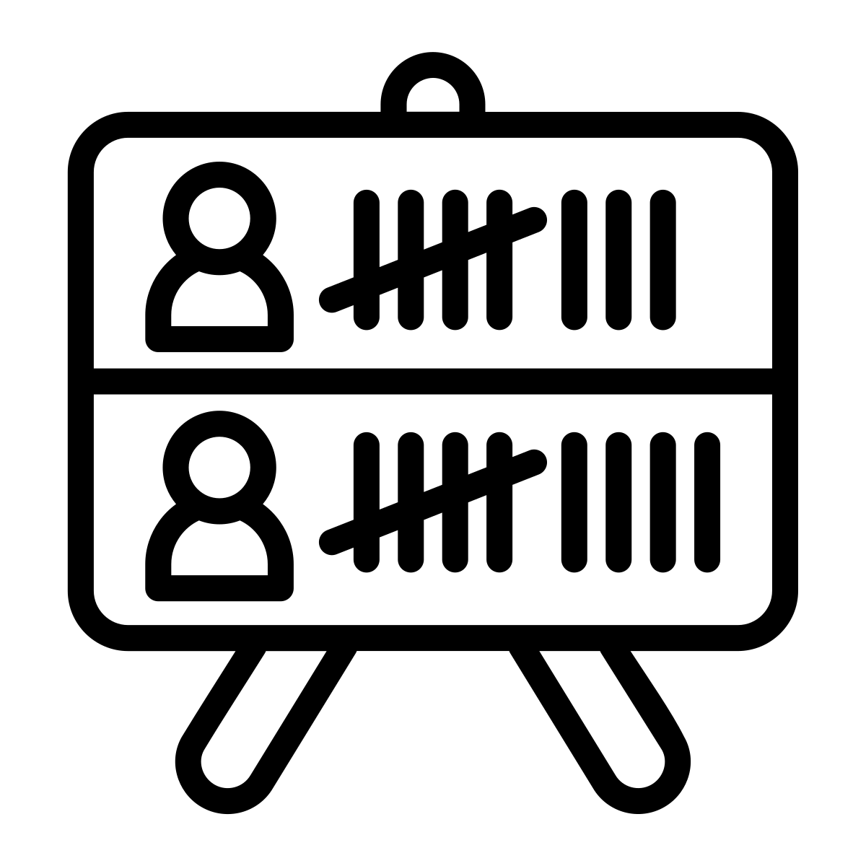 | - Yes  - Maybe  - No
Use math to learn about the data.   | - Yes  - Maybe  - No
Make graphs or other pictures to show the information.   | - Yes  - Maybe  - No
Figure out what the data means (look at the graphs or the numbers to answer the research questions).   | - Yes  - Maybe  - No
Something else: | - Yes  - Maybe  - No

Data analysis with words, pictures, or videos
(qualitative data)
Task | Do we need to do it | Who will do it
Enter the data into a computer program. | - Yes  - Maybe  - No
Make sure that all the data we have is correct.  -The data is from real people.  -There aren’t mistakes. | - Yes  - Maybe  - No
Listen to an audio or video recording and type what people said (“transcribe” the data).   | - Yes  - Maybe  - No
Break a big amount of data into smaller parts we can look at one at a time.  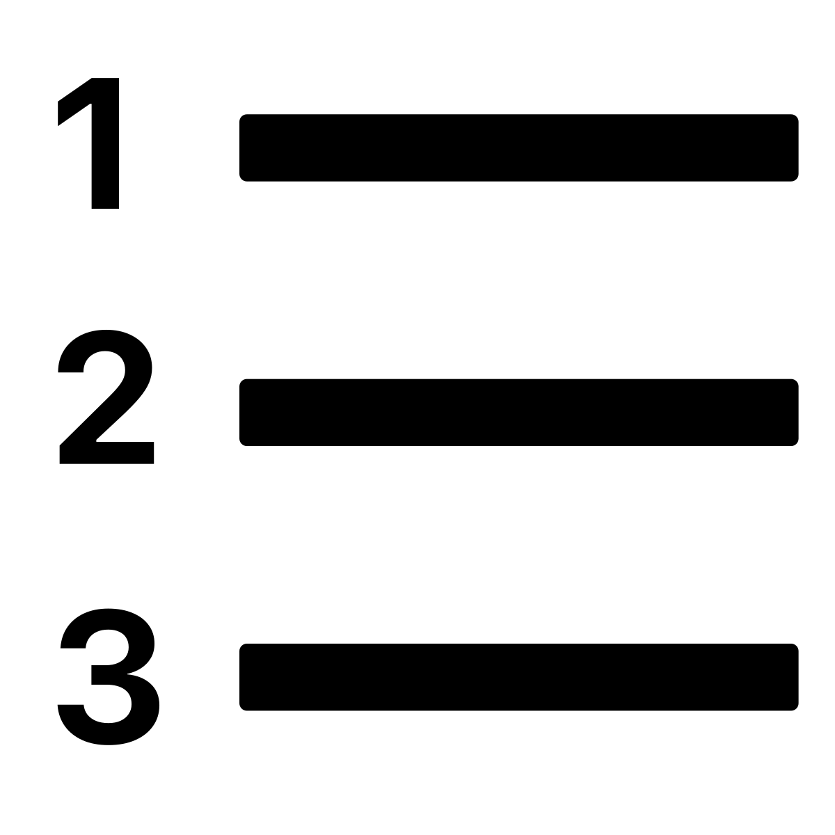 | - Yes  - Maybe  - No
Figure out the main ideas that people shared.   | - Yes  - Maybe  - No
Make “codes” that describe main ideas in the data.  Codes: labels for the main ideas or key points in the data.   | - Yes  - Maybe  - No
Figure out what the data means (look at the main ideas or visuals to answer the research question).   | - Yes  - Maybe  - No
Something else: | - Yes  - Maybe  - No

Information: Making Data Analysis Accessible

Team members who work full time on research can help clean and prepare data to make it easier to analyze for community research partners with intellectual disability. This includes:

Quantitative data – data with numbers

  - Removing outliers based on decisions you made ahead of time, as appropriate for the research question.
    - This means getting rid of data that is really different from all the other data.

  - Creating graphs or other pictures
    - Talk to your team about the type of graph that is easiest to understand.
  - Calculating sums/composite scores if they are the unit of analysis
    - This means adding up all the numbers. You should do this if the sum (or total) is the number that will help you answer your team’s research question.

Qualitative data – words, pictures, videos, etc.

  - Transcribe data (typing what people said).
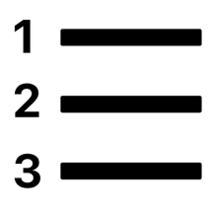
  - Break qualitative data into small chunks for analysis (break data into 1-3 sentences that you can look at step-by-step).
  - Group data into meaningful categories (e.g., positive or negative feedback, interview/focus group questions)

  - Share photos or videos that can help team members remember collecting data
  - Add images to transcripts to help people understand the words
  - Define words in the transcripts
- All types of data:

  - Present data in small chunks
  - Use color coding to group data
  - Provide the opportunity to interact with the data (for example, sort, or write on)

Resources
- The Toolkit for Remote Inclusive Research includes some ideas for making data analysis accessible:
  - Sorting qualitative data
  - Role play
  - Making accessible graphs and charts

Information: Ways to figure out what the information means

There are many ways to figure out what research information tells you or to do data analysis. Your team can talk about some ideas.

Data analysis with numbers

Some data includes numbers. There are different ways to use math and something called “statistics” to figure out what the numbers mean.
- Way to figure out what the numbers mean | - What it can tell us | - Example
- Counting or adding up.  - 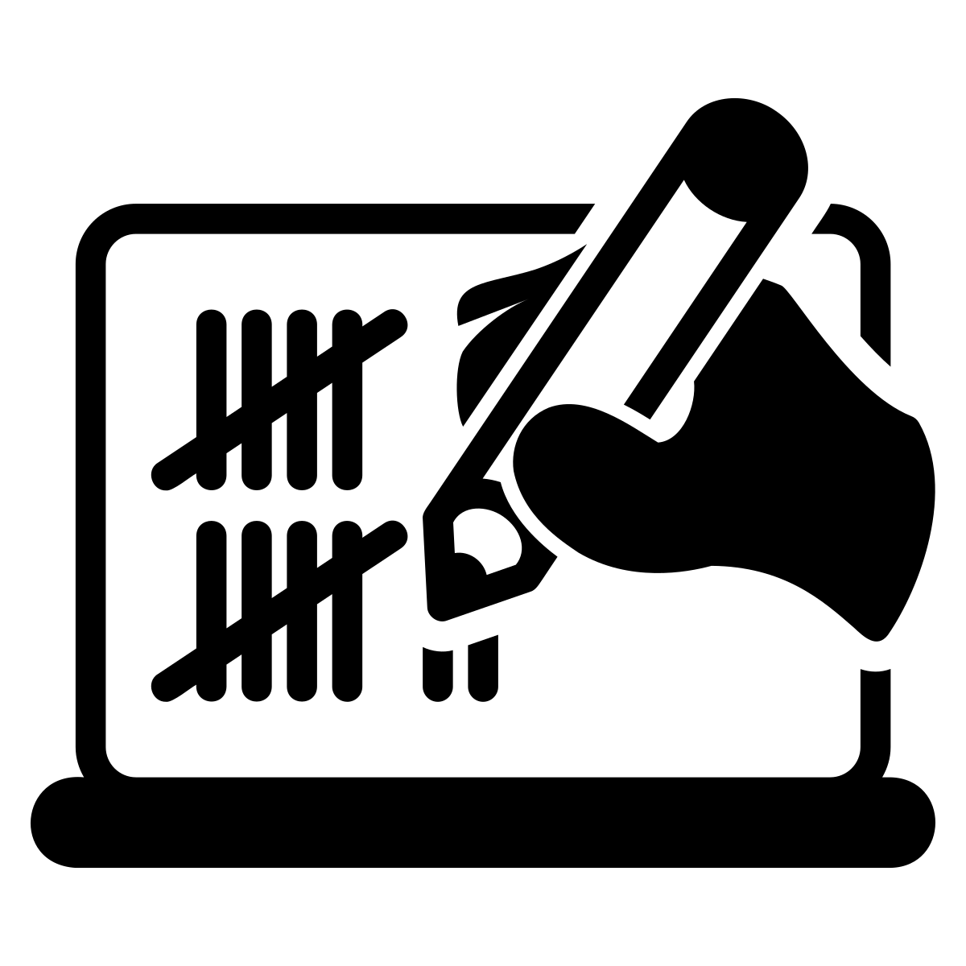 | How often something happens.  How many people have a certain experience. |   How many people with disabilities got the flu shot.  75% of people got the flu shot.
- Finding averages or most common answers.  - 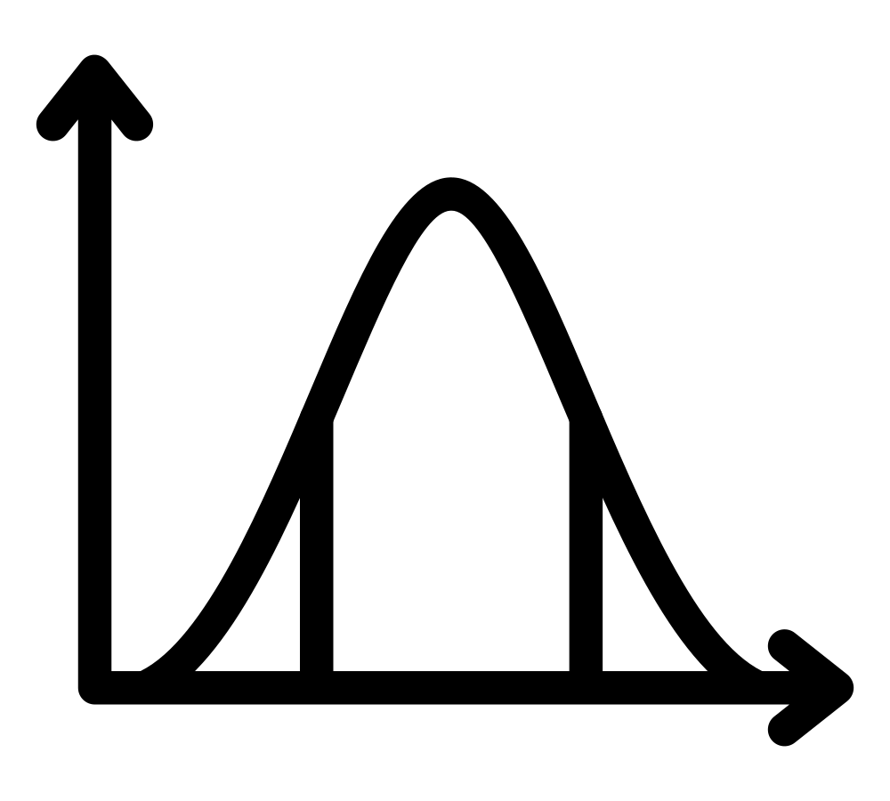 | What is a typical or common thing to happen? |   The average amount of money people get paid hourly.  - On average, people got paid $11 per hour.
- Compare numbers.  - 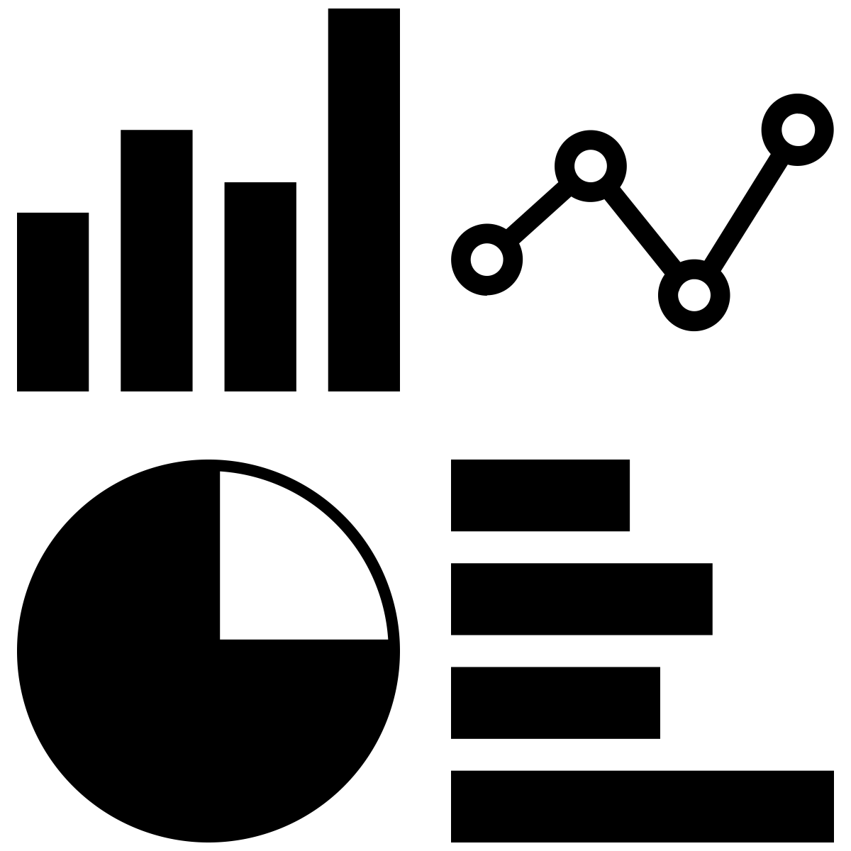 | If two groups are different.  If something improved, got worse, or stayed the same. |   Do people who get physical therapy and use medication have less pain than people who use just medication?  - People who get physical therapy and use just medication had 50% less pain than people who only used medication.
- Look for relationships between numbers or look to see if one thing changes another thing.  - 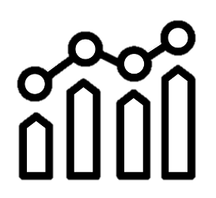 | If two or more things are related.  If one thing causes another thing to happen. |   How is exercise related to how healthy your heart is?  - People who exercised more had a healthier heart.



Data analysis with words, pictures, or videos (qualitative data)
Some data includes words, pictures, or videos. Researchers can look at this information in different ways. Usually this means looking at the words, pictures, or videos for main ideas.
Your team will make plans for how to find main ideas in your data.

Discussion topic: What else do I want to know?

The research question tells us what we will look at in the data to find the answer to our question. Sometimes people have other things they want to know.
I want to know about:
Our data has this information in it
- Yes.
- No.
- I’m not sure.
Your team will talk about if you have time to learn about this other thing.

