Communication Planning
[project logo or short title]
People learn and communicate in different ways.
- Some people learn by reading and other people learn by doing things.
- Some people communicate by writing or typing, or use American Sign Language (ASL), or Augmentative and Alternative Communication (AAC). Think about the ways that you like to communicate.
Directions: Write how you like to learn and share your ideas. If you want, you can cut out the pictures at the bottom of each page. Then, you can tape the pictures into the open space to show how you like to learn and share. Then, you can share your learning and communication choices with your research team.


When I am Working in a Group, I like to learn by…
Options:
Talking with someone else  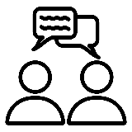 | Watching videos   | Doing things or practicing   | Typing   | Another way:
Writing   | Looking at pictures   | Reading on my own   | Another way: | Another way:


When I am working in 1 on 1, I like to learn by…
Options:
Talking with someone else | Watching videos | Doing things or practicing | Typing | Another way:
Writing | Looking at pictures | Reading on my own | Another way: | Another way:

What other ways do you like to learn? Write your ideas on the lines below.

When I am Working in a Group, I like to share my ideas by…
Options:
Talking out loud | Making videos | Writing | Typing
Having time to plan and think ahead  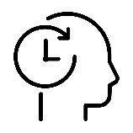 | Drawing pictures | Another way: | Another way:

When I am working 1 on 1, I like to share my ideas by…
Options:
Talking out loud | Making videos | Writing | Typing
Having time to plan and think ahead | Drawing pictures | Another way: | Another way:

What other ways do you like to communicate? Write your ideas on the lines below.

