Who Should be an Author?
[Project Logo or Short Title]
Instructions to tailor this worksheet: This agreement can be used to guide discussion around authorship. Modify this document as needed for your study. This may include reducing items in the lists or adding additional criteria for authorship.

This worksheet includes two types of things:
Image | Description
 | Information to read on your own or together
 | Discussion topics to talk about with your team

Authorship Agreement
[Project Title and Logo]
Person leading the project: [name, photo]
Community research partner: [name, photo]

Information: What makes someone an author?
Image | DESCRiption
 | Authors are the people who share what was learned in a research study.
 | Authors take responsibility that what is shared is correct.  Being an author is important because it helps people know about your work.
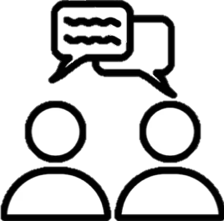 | Talk with your project leader and research team about authorship after your team decides what each person will do as part of being on the research team.  Your team will talk again as you get ready to share what you all learned.  Your team might review this if new people join your team or people leave.  You might also want to look at this document each time your team makes something new to share about your research.

To be an author, you must:
- Help with at least 1 of these:
Image | Description
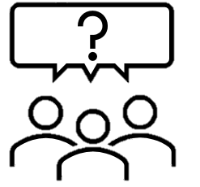  ↓   | Plan the research study, including:  - Having ideas about the research question, or programs/treatments your team wanted to learn more about;  - Making a treatment program;  - Giving ideas for how to answer the research question;  - Making the things we use to answer the research question (for example, surveys, interview questions, ways to look at a dataset, etc.);  - Picking information we need to answer the research question (for example: the “variables” we look at or the things we measure);  - Making a step-by-step plan for people to be included;  - Deciding who should be included in the study;  - Making a plan to find people to be in the study.
 | Getting the information to answer the research question (data collection), including:  - Giving people surveys (in-person, online, telephone);  - Asking people questions in interviews or focus groups (in-person, online, telephone);  - Giving people the program or treatment;  - Picking what dataset to use;  - ______________________________.
 | Figuring out what your team learned from the information you all collected (data analysis or interpretation), including:  - Giving feedback on a summary of the data;  - Thinking about what the things your team learned might mean for people, policies, or services;  - __________________________.

- Help make the materials your team is sharing.
Image | Description
   | - Helping think about what we will share;  - Giving feedback on the ideas in the research publication;  - Writing parts of the research publication or saying what we should write;  - Giving approval for the publication;  - If my team needs feedback about the information we are sharing, I need to respond on time. If I do not respond in [insert number of weeks] weeks, I might not be able to be an author anymore.

- Be responsible for the research
Image | Description
 | - If there are questions about the research, you will try your best to answer them.  - If someone finds out you did something unethical in the research, you will take responsibility.

Discussion: Conversations your team can have about being an author
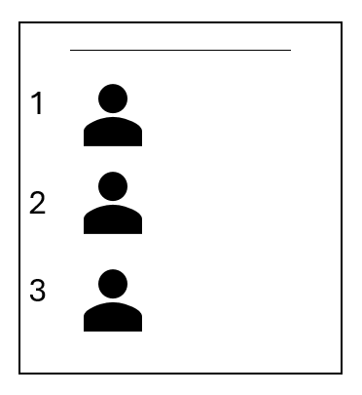
Our names will be listed on the product we make. Our team will decide whose name is listed first, second, third, all the way to last by:
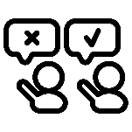
If we disagree about who is an author or the order they are listed, we will:


Sometimes, we can’t list everyone’s name. We will sometimes use a team name and then list everyone’s name who is part of that group. We will do this if:

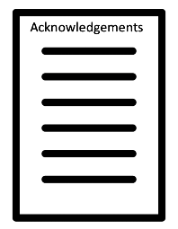
Sometimes people helped the research in small ways. These people did not do enough to be an author. We can list these people’s names in the “acknowledgements.”
- Acknowledgements means thanking people for what they did.
- We will list people’s names in the “acknowledgements” when...
- Note: some journals require people to agree to be acknowledged and their name to be printed.

Getting Paid for your Work
Talk with your team about if and how you will get paid for the work you do to share about research.
I will get paid: (circle or highlight all that apply)
- ___________ for each meeting I attend.
- ___________ for each hour I work.
- ___________ for all the work we do to share about research.
- Being an author is part of my regular pay.
- Something else:
Directions: Circle or highlight how you will get credit for the work you do.
- I will be an author.
- I will be listed in the acknowledgements.

Signatures

Signature Date
If you don’t want to sign, but still agree, let someone know and they will write down the date you agreed.

Project leader signature Date

