Accommodations Checklist
Directions: Circle or highlight the things that will help you prepare for meetings, understand information, and share your ideas.

Before meetings
 | Description
 | Support to review materials before meetings  - 1 on 1  - Group
 | Explain what to expect at the meeting  Who will be there  Why we are meeting  What we will do
 | Make plans for service and emotional support animals  - Plans for animals to go to the bathroom  - Plans for people allergic to animals  - Plans for people uncomfortable with animals
Something else

During meetings
Image | Description
 | Breaks during meetings
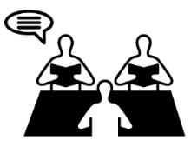 | Read materials out loud
 | Help people know when to talk
 | Use clear language when people talk
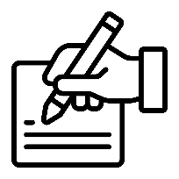 | Someone to write for me
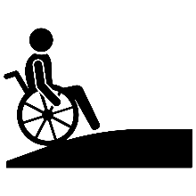 | Physical accessibility  Examples:  - Big enough places to move  - Accessible bathroom  - Elevators in the building
 | American Sign Language interpreter
 | CART (Communication Access Realtime Translation)
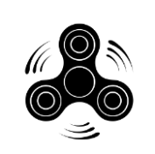 | Have fidgets I can use
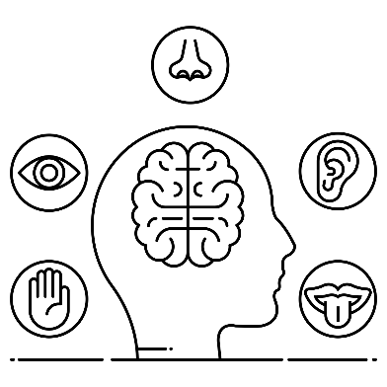 | Sensory accommodations (things related to lights, sounds, smells, touch)  Examples:  - Fidgets  - Noise canceling headphones  - Large font  - Rules about scents people can wear  - Dim or natural lights  - Quiet break room  - Ball or rocker chair
 | Have food and drinks for health available
 | Give everyone enough time to think and communicate.
 | Do things step-by-step
Something else

Meeting materials
 | Description
 | Use clear language
 | Include pictures
 | Have paper copies of materials
 | Large font for printed materials
 | Large font for electronic materials
 | High contrast colors
 | Materials that work with a screen reader
Something else

