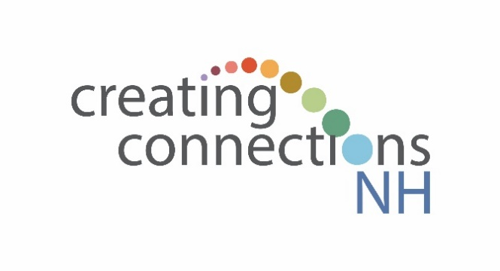

Alternative Peer Group Intake Form

Participant ID:

Today’s Date:

THIS SURVEY IS ENTIRELY VOLUNTARY. IF ANY OF THE QUESTIONS MAKE YOU UNCOMFORTABLE, PLEASE FEEL FREE TO SKIP IT. YOUR RESPONSES WILL BE KEPT PRIVATE. THEY WILL NOT BE LINKED TO YOUR NAME AND WILL ONLY BE REPORTED IN THE AGGREGATE (I.E., AVERAGES, PERCENTAGES, ETC.).

PLEASE INDICATE THE RESPONSE THAT BEST DESCRIBES YOUR CURRENT SITUATION. | Strongly Agree | Agree | Neither Agree nor Disagree | Disagree | Strongly Disagree
- I am in good physical health.
- I feel safe and secure in my neighborhood.
- I have a close relationship with someone in recovery.
- The stories and experiences that members of my recovery support community share with me give me hope.
- I participate in social activities with other youth who are supportive of my recovery.
- I have a clear sense of who I am.
- I feel safe and secure at home.
- My family has enough money to meet my needs such as clothes and food.
- My parents/caregivers have access to family recovery supports.
- I know that my life has a purpose.
- There are adults in my life who want me to be successful.
- I feel able to manage the stress caused by events or situations in my life.
- My parents/caregivers know where I am most of the time.
- I have no difficulty seeing a doctor or nurse when I need to.
- I do well in school.
- There are recovery supports available in my community that fit my beliefs and values.
- I have goals for what I want to accomplish in the future.
- My parents/caregivers and I can work through things we don’t agree on.
- I have access to recovery supports at my school.
- I have a peer recovery leader or coach that I can turn to for support and guidance.
- At least one of my parents/caregivers has a good job.
- I find it easy to make new friends.
- We have clear rules in my house and I know what will happen if I break a rule.
- I have family members who are supportive of my recovery.
- I believe that I’ll accomplish the goals that I have for the future.
- If I wanted to get some alcohol (beer, wine, or liquor), it would be easy for me to get some.
- My parents/caregivers have flexibility so they can take me to meetings and appointments.
- I understand what leads me to use alcohol or other drugs.
- Sometimes it may be okay to share my substance use story with others but there are some situations where sharing may have negative results for me or for others.
- Other people are affected by what I say or do.
- I practice self-care activities that improve my health and wellness.
- If I wanted to get some marijuana, it would be easy for me to get some.
- I can recover from mistakes that I make without feeling ashamed.
- I have personal connections that I can reach out to when I feel lonely.
- I am good at standing up for myself and making myself heard.
- Generally, I can manage my emotions well.
- I have access to technology that helps me be connected, like a cell phone, tablet, or computer.
- I enjoy spending time with my family.

THE FOLLOWING INFORMATION WILL HELP US MAKE SURE THAT OUR PROGRAM IS SERVING ALL YOUTH WHO NEED IT, REGARDLESS OF WHO THEY ARE. YOUR RESPONSES WON’T BE LINKED TO YOUR NAME AND WILL ONLY BE REPORTED IN THE AGGREGATE (I.E., AVERAGES, PERCENTAGES, ETC.). IF YOU PREFER NOT TO ANSWER ANY OF THE QUESTIONS BELOW, PLEASE FEEL FREE TO SKIP IT.
What is your gender? Male Female Other (please specify___________________)

Are you Hispanic or Latinx? Yes No

What is your race (Mark all that apply)?
Black or African American Alaska Native
Asian American Indian
White Native Hawaiian or Other Pacific Islander
Another race (please specify________________________________________________)

Which of the following best describes how you would identify your sexual orientation? (Select only one)
Heterosexual (straight)
Gay or lesbian
Bisexual
Not sure
Other (please specify________________________________________________)

If you are currently participating in a substance (SU) use or mental health (MH) treatment program, mark all of the options below that apply to you. If you don’t participate in any SU or MH treatment programs, do not answer this question.
I’m in a residential treatment program
I attend individual or group counseling
I’m in a Medication Assisted Treatment Program (MAT), i.e., I’m taking a medicine such as methadone, Vivitrol, Naltrexone, or a similar anti-craving medicine under a doctor’s supervision
I attend a support group. Please describe the type of group (e.g., 12-Step, SMART Recovery, grief support) __________________________________________________________________
I have a recovery coach or peer support leader
I participate in another type of SU or MH treatment program
(please specify your program __________________________________________________
__________________________________________________________________________)

Thank you for participating in this survey!

