Concord Commons “A” RENEW Pilot Team
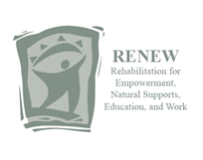
Mission: The Common’s A pilot RENEW team will support the implementation of RENEW in order to deliver RENEW services to youth who are at risk so that they are successful in and outside of school.

Activities:
- Determine criteria for success of the pilot
- Develop a data tracking system
- Learn implementation strategies (attend IOD trainings: RENEW Implementation, Behavior Support Team, & Universal Implementation of Multi-tiered Systems of Support)
- Develop selection criteria for youth to be served with the RENEW intervention
- Identify good candidates to be trained as facilitators
- Strategically match youth with trained facilitators
- Share outcomes, successes, lessons learned with the 2012 Concord Implementation Team

Team Members: Tom Crumrine, Jesse Camacho, Betsy Peabody, Rebecca Schaefer
Quarterly Members: Michele Speckman & Steve Rothenberg

